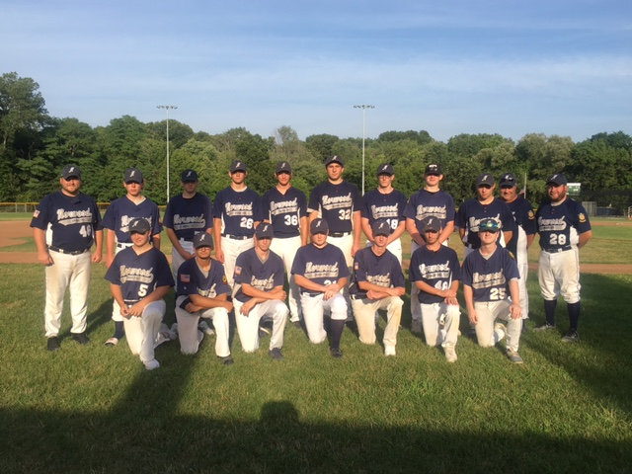

Front row: Paul Manning, Tiago Gomes, Kyle Mackie, Matt Jeannetti, Brian Gunning, Tim Denehy, Ryan Crowley. Back row: Manager Dan Harrington, Kevin Costello, Charlie Gover, Jay Wladkowski, Paul Murphy, Cam Flahive, Mat Rice, Sean Munro, Mike Dooley, Coach Bob Harrington, Coach Bobby Harrington.

