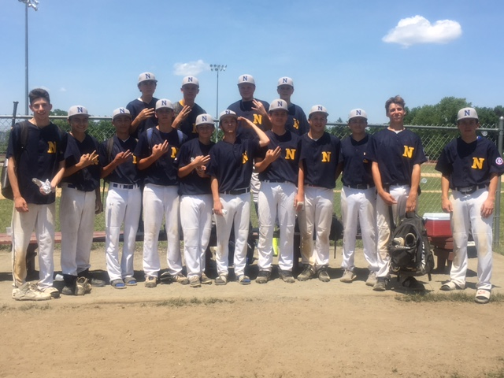Courtesy of Holly Denehy Photography

