How to Zoom in-and-out on a .pdf

Either ---(double-click on 'Download (PDF, unknown)' under picture.)

OR

Zoom-in on the .pdf’s to make them easier to read. Place your cursor/arrow over the upper righthand corner of the PDF frame until you see the magnifying glass – click on the magnifying glass then…

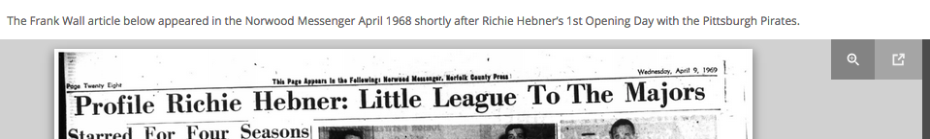

… use the slide to the left of the magnifying glass to make the print bigger. You will need to scroll up-and-down but you will not require an actual magnifying glass to read it.

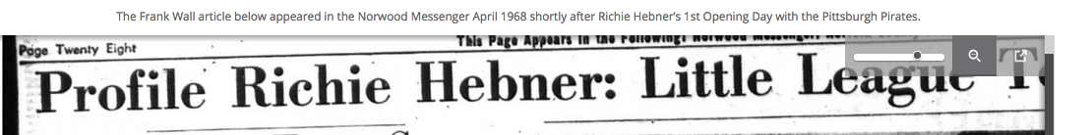

If this did not help, please let me know using ‘Contact’. Thanks

